**User Manual for Learning LMS Offline**

This user manual provides a step-by-step guide to access and learn from the Saya Foundation's offline LMS course: Clear Blue Sky. By following the instructions below, you will be able to register, access, download and learn the course materials offline.

# Accessing the Offline LMS Course

* Copy the offline LMS course link: [Clear Blue Sky (Offline)](https://saya-foundation.org/courses/clear-blue-sky-offline/)
* Paste the link in Chrome browser search bar and the course page will be displayed.

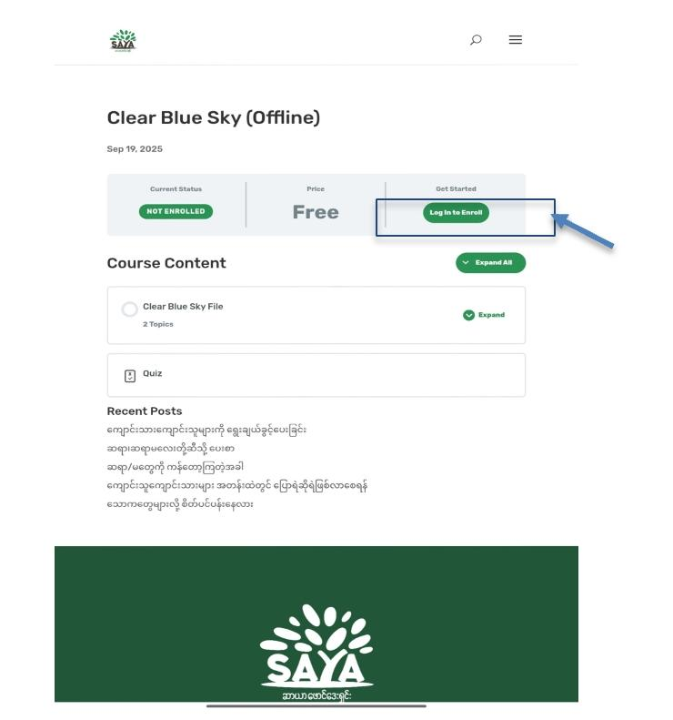

* Click 'Login to Enroll'.
* A page including 'Login' and 'Register' will be displayed.
* If this is your first time accessing Saya Website, click 'Register an Account'.
* Click 'Continue with Google'.

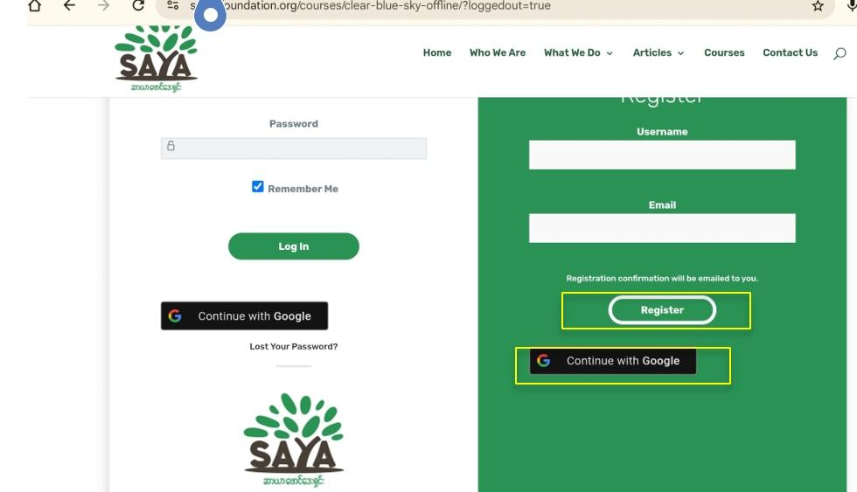

* Choose an account you want to use for access.
* You will be redirected to the course page again.
* Click 'Take this Course'.

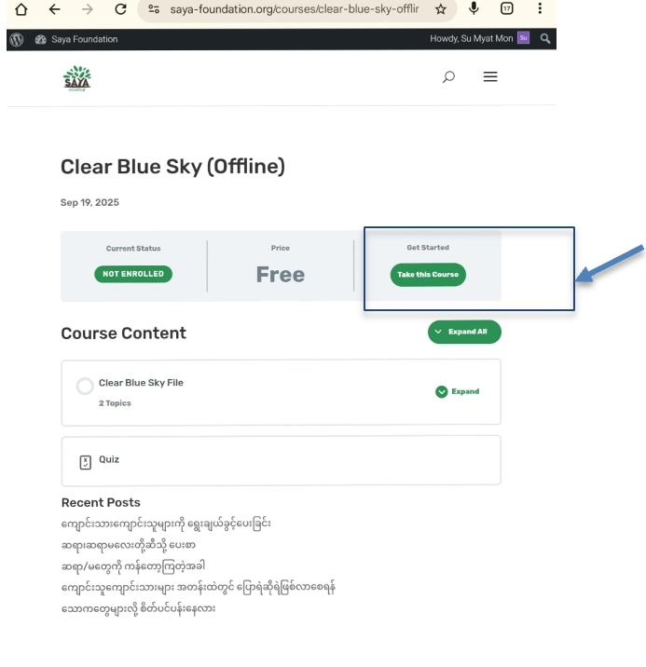

* You can start learning at your own pace.

# Accessing Course Content

* Upon getting access to the Offline LMS course, you will be able to see 'Course Content'.

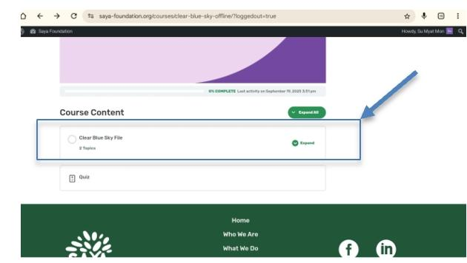

* Click 'Clear Blue Sky' file topic to see the available files you can download.
* First, go to 'User Guideline', download the file with your preferred version and read the tutorials to learn offline.

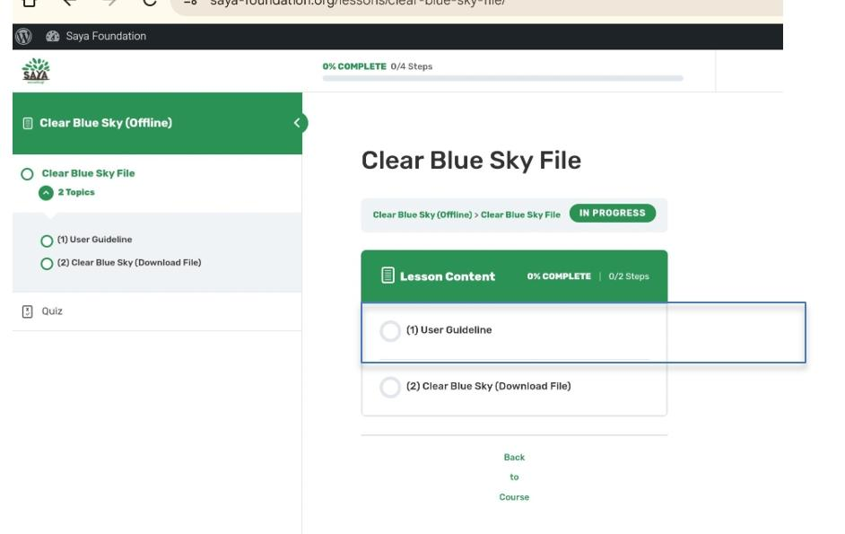

* Then, go to 'Clear Blue Sky (Download File)'. Click the 'Download Clear Blue Sky' blue label to start downloading the zip file of the whole course.
* The zip file will start downloading once you click the blue label.
* Once downloaded, click the downloaded zip file to extract and then select the folder.

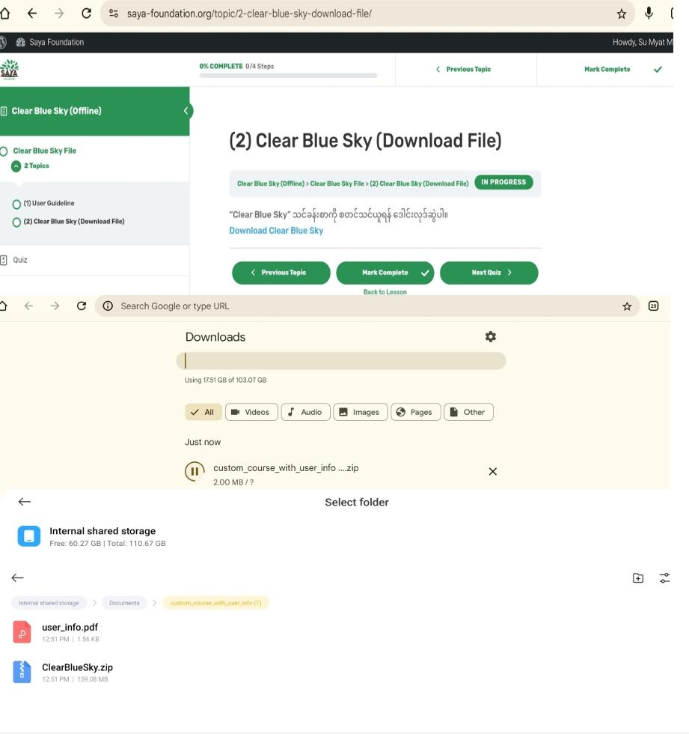

* The extracted folder will contain 2 files: one 'user_info.pdf' which includes your user ID and username.

**Sample User Info PDF**

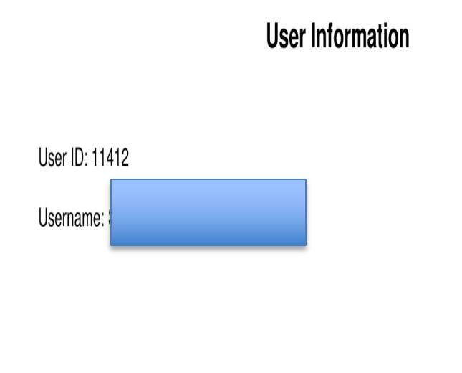

* Extract ClearBlueSky.zip file again (direct to the same path which locates the zip file of Clear Blue Sky and User info).
* The contents will be displayed as HTML files (1.1 would be topic 1.1 and the order goes sequentially).

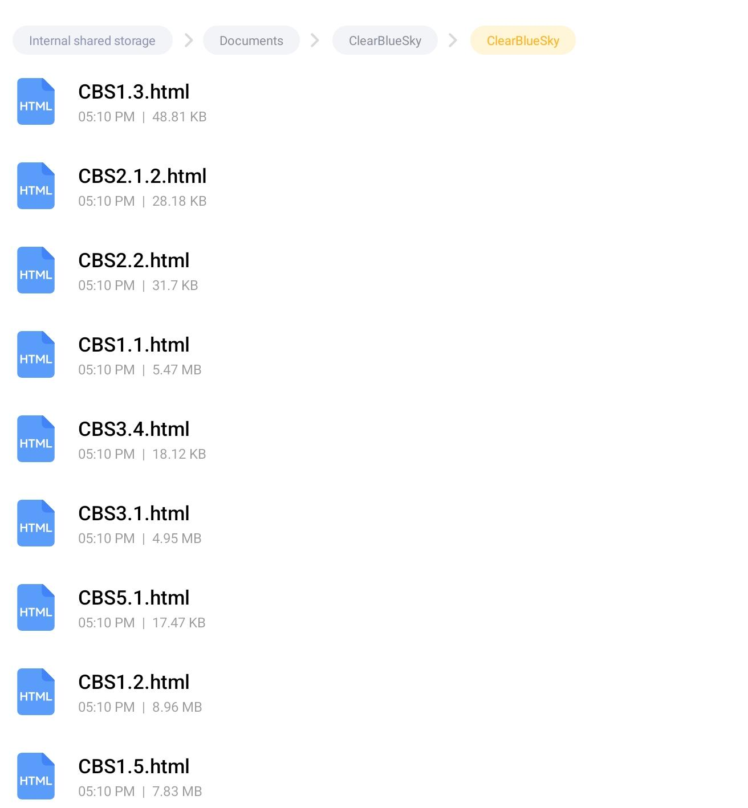

* Once you click the file and choose “Chrome” to take the course offline, you can start learning and taking quizzes offline.

# Taking Quizzes and Exporting Results

* Please enter your username before learning or taking any quizzes.

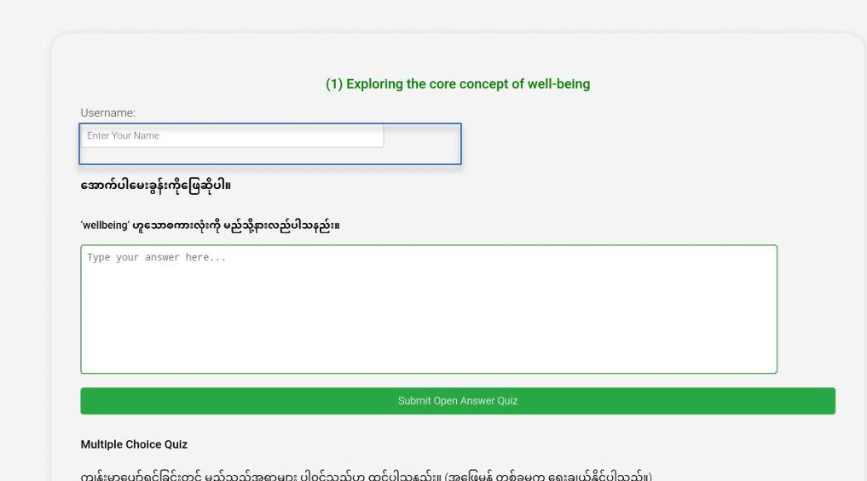

* Whenever you take each quiz, remember to click 'Submit Quiz' button so that your answers will be recorded one by one.
* When you finish taking all quizzes, please click 'Export Results' button.
* Choose the same file path as your user info and course folder to store your exported results file.

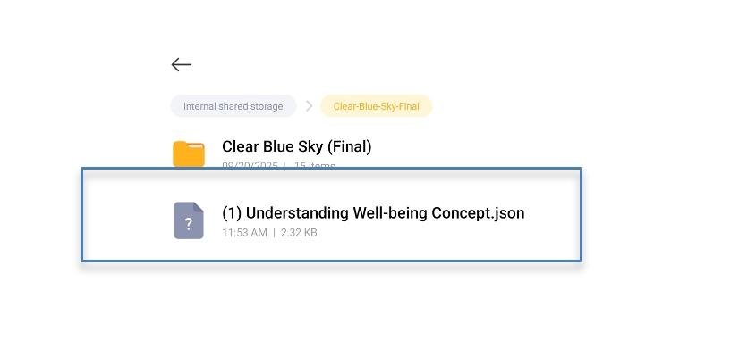

* 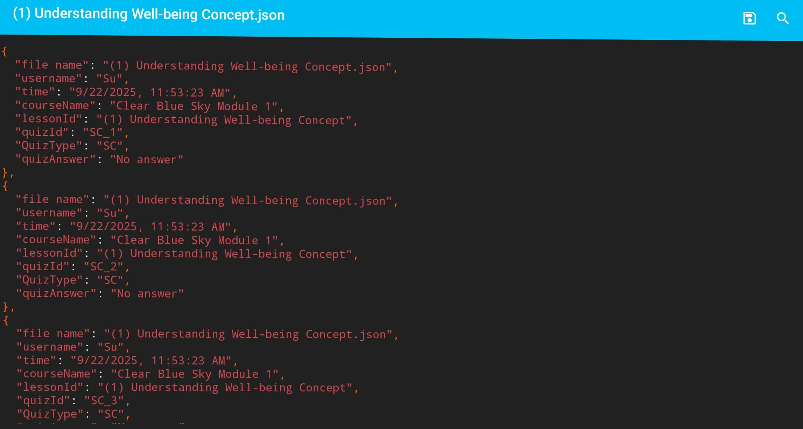The exported results will include your name, the time you took the quiz and your selected answers.